Healthcare Analytics &
Intelligence Platform (HAIP)
Weeks 2 & 3 — Technical Report
Refinements + Knowledge Intelligence System (RAG)
Full build documentation: completed work, tool & method comparisons, system flowcharts, and benchmark evaluation

Table of Contents

1. Introduction
This report documents the work completed across Week 2 and Week 3 of the HAIP capstone. Week 2 closed outstanding refinement tasks on the analytics and machine-learning platform; Week 3 built a complete Retrieval-Augmented Generation (RAG) knowledge-intelligence system. The two weeks are reported together because the Week 2 refinements were finalised alongside the Week 3 build.
The report covers, in order: the Week 2 tasks that were adjusted and completed; the Week 3 RAG build against its specification; a detailed comparison of every tool and method selected inside the RAG pipeline with the rationale for each choice; the full system flowcharts (module-by-module and end-to-end); and the benchmark evaluation with measured results.

1.1 Guiding constraints
Every technical decision in both weeks was shaped by three constraints specific to this project:
- Hardware: a RAM-constrained development laptop (7.4 GB), ruling out heavyweight local models and large batch sizes.
- Cost: a student capstone with no paid-API budget, favouring free and open tooling.
- Honesty: every claim the system makes must be traceable to a source, and performance must be measured and reported truthfully — including weak or negative results.

2. Week 2 — Completed Refinement Tasks
Week 2 had several pending items carried forward. All were adjusted and completed. This section documents what each task was and how it was resolved.

2.1 Dashboard consolidation
Two separate Plotly Dash applications (clinical analytics on port 8050, data-upload on port 8051) were merged into one application with two tabs: Clinical Analytics, and Data Intake & Prediction. Lazy tab loading was added so each tab's layout builds only when first opened, keeping startup light on the constrained machine.

2.2 Feature caching (performance)
The feature matrix was being rebuilt on every call, costing about thirteen seconds each time and making evaluation slow. An in-memory base-frame cache with an explicit clear function was added. The first call still takes about thirteen seconds; every subsequent call returns in roughly one millisecond, verified live.
Operation | Before | After
First feature build | ~13 s | ~13 s (unchanged)
Repeat feature access | ~13 s each | ~1 ms (cached)
Evaluation / cross-validation | minutes | seconds

2.3 Honest evaluation — confusion matrix
To address the concern that the system always reported high performance, a model-evaluation panel was added to the analytics tab. A dropdown selects a prediction target and shows that target's best-model confusion matrix as a heatmap, computed live and cached. False negatives are highlighted as the costliest clinical error. The deterioration target, for example, summed to the full 20 percent holdout with roughly 54 percent recall — an honestly mediocre figure, shown deliberately rather than hidden.

2.4 The four risk targets
The machine-learning layer predicts four targets, each reported with imbalance-appropriate metrics (PR-AUC where classes are skewed), with time-leakage guards and cross-validation.
Target | Headline metric | Note
Readmission | PR-AUC 0.64 | Moderate, realistic
High cost | PR-AUC 0.88 | Strong
Deterioration / trauma | PR-AUC 0.63 | Moderate; disclosed
Mortality | PR-AUC 0.42 | Weak; openly disclosed
Disclosing the weak mortality target rather than hiding it is a deliberate honest-engineering choice.

2.5 Visual restyle
A shared theme module was created so all eighteen figures share consistent fonts, hairline grids, hover behaviour, and a common colour sequence. The stylesheet gained more whitespace, softer shadows, CSS variables, and section dividers. Inline SVG KPI icons were added and a donut-chart label-collision bug was fixed by moving labels inside slices and the legend to the bottom.

2.6 Repository cleanup
Pushes were failing because roughly three gigabytes of data (Synthea CSVs, a 596 MB Arrow dataset, a JAR) had been committed. A gitignore was added, the data untracked, and the files purged from all history with git filter-repo. The repository shrank from gigabytes to about 2.6 MB, and the clean history was force-pushed and re-linked. All four Week 2 pending items — import-and-predict, accepting external data, the confusion matrix, and honest metrics — were closed and committed.

3. Week 3 — RAG System Against Specification
Week 3 built a healthcare knowledge-retrieval and question-answering system. This section maps the official specification to what was delivered.

3.1 Activities and acceptance criteria
Spec requirement | Status & evidence
Process medical documents | Done — 6,832 chunks from WHO/CDC/NICE guidelines
Generate embeddings | Done — Sentence Transformers, 384-dim
Create vector index | Done — FAISS IndexFlatIP
Integrate LLM for RAG | Done — Gemini, grounded and cited
Module flowcharts | Done — see Section 5
Relevant context retrieved | Done — Hit Rate@5 93.3% (Section 6)
Questions answered from knowledge | Done — 15/15 answered with citations

3.2 Tools required for comparison
The specification named five tools to compare: PyMuPDF, Sentence Transformers, FAISS, OpenAI GPT / Qwen, and LangChain. All five are evaluated in Section 4. Two deliberate, documented deviations: Gemini was chosen over OpenAI/Qwen for its permanent free tier; and LangChain was added as a parallel implementation rather than the primary engine, so the project has both a hand-built and a framework-based RAG engine.

4. Tool & Method Comparisons (RAG Internals)
This section examines every component inside the RAG pipeline: what it is, how it works, the alternatives considered, and why the final choice was made. This is the research-then-build evidence required by the specification.

4.1 PDF extraction — PyMuPDF
PyMuPDF (the 'fitz' library) is a fast C-backed library that extracts text and layout from PDF files. The base corpus arrives pre-extracted as text, so live PDF parsing was not needed for the build; PyMuPDF is instead exercised by the hospital-document upload feature, where uploaded files are genuine PDFs that must be parsed.
Tool | Why considered | Decision
PyMuPDF | Fast, accurate, complex layouts | Selected; used in hospital upload
pdfplumber | Strong table extraction | Slower; not needed for prose
pypdf | Lightweight | Weaker on complex layouts
Unstructured.io | Many formats | Heavy dependency for the hardware

4.2 Chunking strategy
Chunking is the largest single lever on retrieval quality. An advanced recursive strategy was chosen over naive fixed-size splitting.
Strategy | How it works | Trade-off
Fixed-size | Cut every N characters | Simple; severs ideas mid-sentence
Recursive (chosen) | Split on coarsest natural boundary that fits, with overlap | Keeps ideas together; slightly more complex
Semantic | Embed sentences, split where meaning shifts | Highest coherence; extra embedding pass, costly on RAM
Recursive character chunking with ~500-token chunks and a 200-character overlap was selected: a genuine step above fixed-size splitting, light enough for the hardware, with overlap so facts split across a boundary are not lost.

4.3 Embedding model — Sentence Transformers
Sentence Transformers is the standard open-source embedding toolkit. The specific model balances retrieval quality against memory.
Model | Dim | Size | Fit
all-MiniLM-L6-v2 (chosen) | 384 | ~80 MB | Fast on CPU, low RAM, strong retrieval
all-mpnet-base-v2 | 768 | ~420 MB | More accurate; ~2x memory/time
BGE / E5 large | 1024 | ~1.3 GB | State-of-the-art; too heavy for 7.4 GB
OpenAI text-embedding-3 | 1536 | API | Strong; paid and off-device
all-MiniLM-L6-v2 encodes the 6,832-chunk corpus in about three and a half minutes on CPU; its 384-dimensional vectors proved more than sufficient, reaching a 100 percent hit rate before re-ranking.

4.4 Vector store — FAISS
FAISS (Facebook AI Similarity Search) indexes the embeddings for fast similarity search.
Option | Why considered | Decision
FAISS (chosen) | In-memory, fast, serverless, exact | Selected — ideal for ~7k vectors on a laptop
pgvector | Inside existing PostgreSQL | Deferred — DB round-trips; revisit at scale
Chroma | Persistent, friendly | Unnecessary abstraction at this scale
Pinecone / Weaviate | Managed, scalable | Cloud cost; over-engineered for a capstone
An exact inner-product index (IndexFlatIP) on normalised vectors gives cosine similarity with no approximation error and sub-millisecond search at this scale. Approximate indexes (IVF, HNSW) only pay off at millions of vectors.

4.5 Re-ranking — cross-encoder (advanced RAG)
A two-stage retrieval design is the core advanced-RAG component:
- Stage 1, bi-encoder retrieval: FAISS returns a wide net of 20 candidates quickly but approximately.
- Stage 2, cross-encoder re-ranking: a cross-encoder (ms-marco-MiniLM-L-6-v2) jointly scores each query-passage pair, far more precisely, and keeps the best 5.
A bi-encoder alone is fast but imprecise; a cross-encoder alone is precise but too slow at corpus scale. Together, FAISS narrows the field and the cross-encoder selects the winners. The measured effect of this stage is reported honestly in Section 6.

4.6 LLM provider — Gemini (vs OpenAI / Qwen)
The generation step is provider-flexible; swapping backends is a one-line change.
Provider | Why considered | Decision
Gemini 2.5 Flash (chosen) | Free tier, no card, strong grounding | Selected — only no-cost viable option
Anthropic Claude | Cautious, strong grounding | Swappable; requires paid credits
OpenAI GPT | Large ecosystem | Swappable; requires paid credits
Local (Qwen, Llama) | Free, offline, private | Rejected — 7.4 GB RAM cannot run a usable model
Privacy note: the corpus is public guideline text, not patient data, so sending retrieved passages to a cloud LLM raises no confidentiality concern. The grounding prompt instructs the model to answer only from retrieved context and to decline when the answer is absent, preventing invented clinical detail.

4.7 LangChain — parallel framework implementation
LangChain was added as a second, parallel RAG engine (rag_engine_langchain.py) alongside the hand-built one. The hand-built engine demonstrates understanding of the internals (manual FAISS search, manual re-rank, manual prompt assembly); the LangChain version demonstrates fluency with the standard industry framework, wiring the same components through an Embeddings wrapper, a FAISS vectorstore and retriever, a chat model, a prompt template, and an LCEL chain. The hand-built version keeps the cross-encoder re-ranking that LangChain does not provide out of the box. Having both is a deliberate depth-plus-breadth choice.

5. System Flowcharts
This section presents the complete system visually: first the full end-to-end RAG flow, then each module in turn, and finally the optional hospital-upload module.

5.1 Full system flow (end to end)
The diagram below shows the entire Week 3 system in one view: build-time indexing, query-time answering, the optional per-hospital upload, and the evaluation harness, all feeding the Streamlit demo.
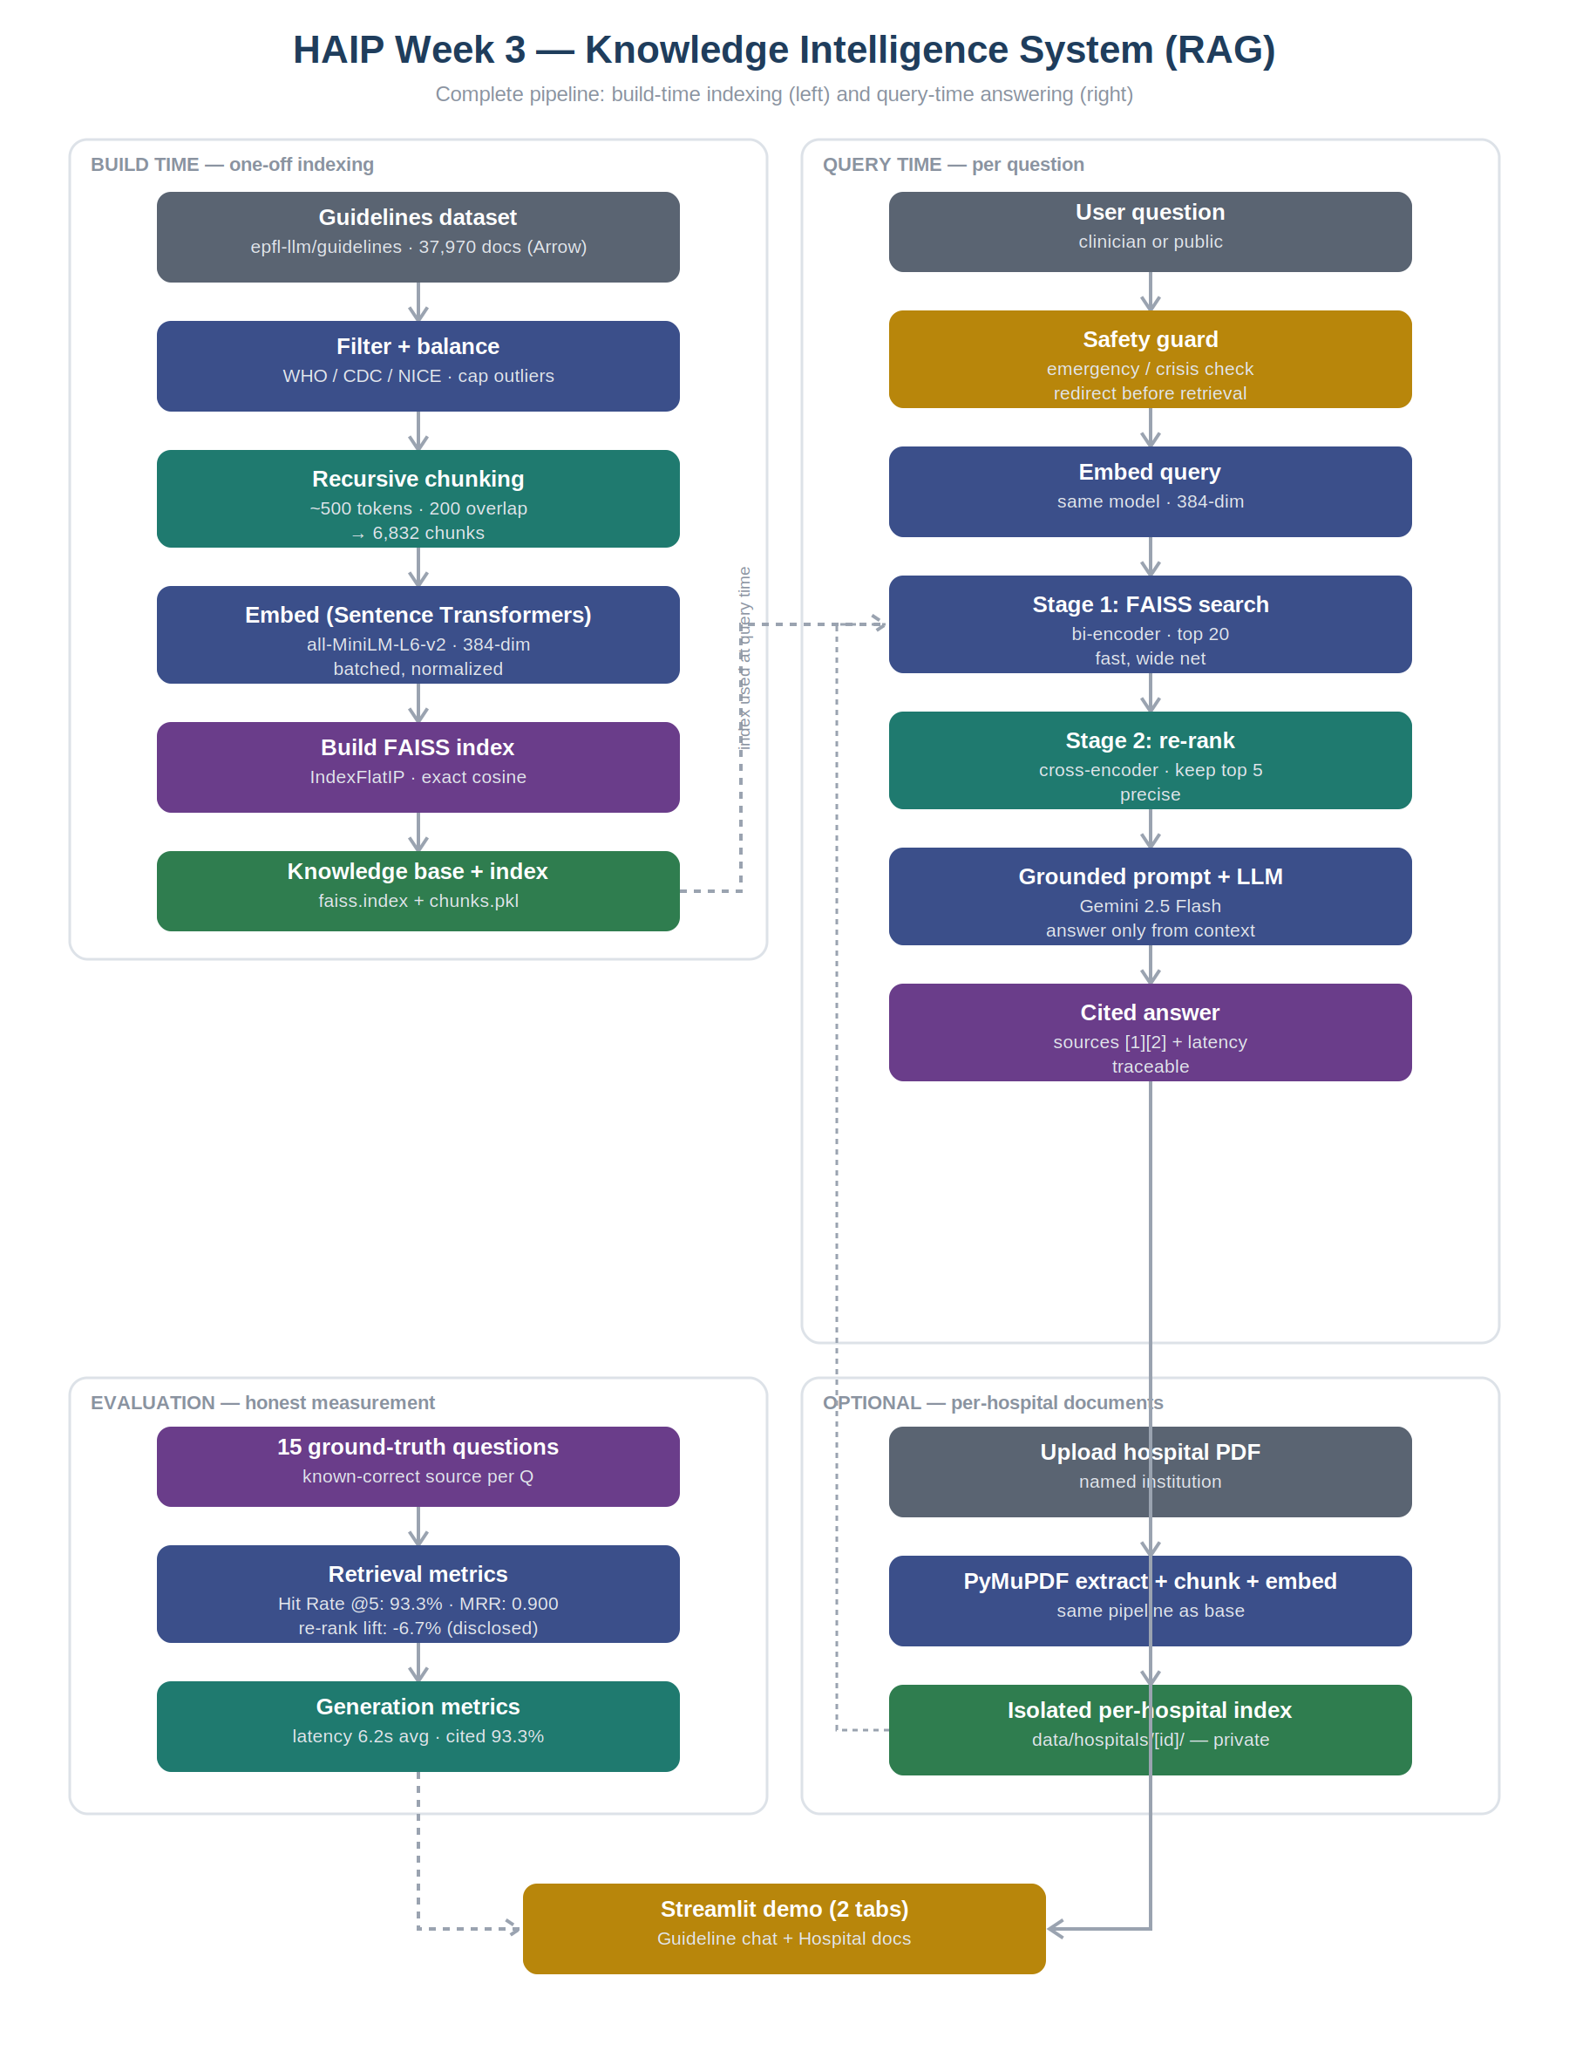
Figure 1 — Complete Week 3 RAG system (build, query, upload, evaluation).

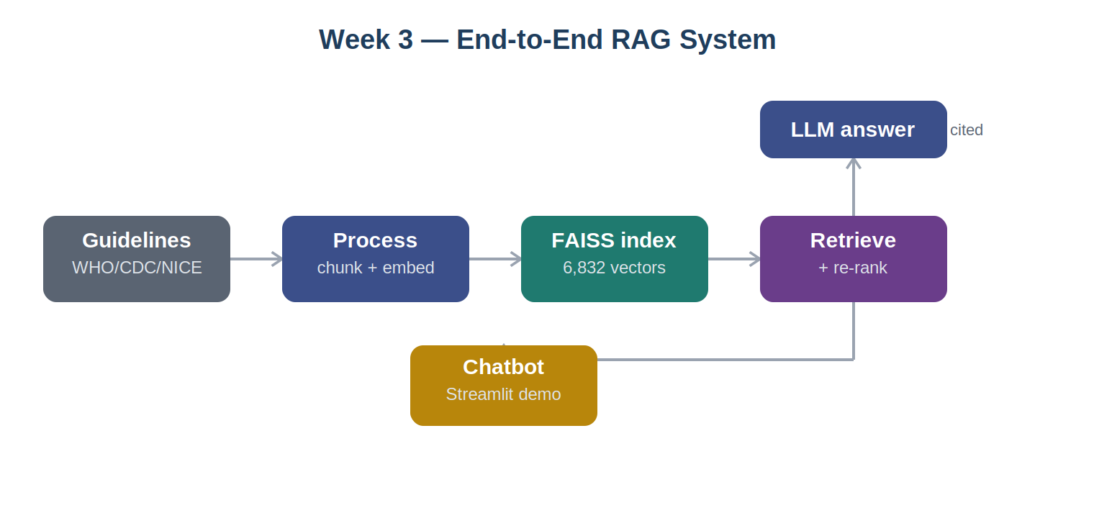
Figure 2 — Simplified end-to-end pipeline overview.

5.2 Module 1 — Document processing
Loads the guideline dataset, filters to trusted sources, balances and caps oversized documents, cleans the text, and chunks it into the knowledge base.
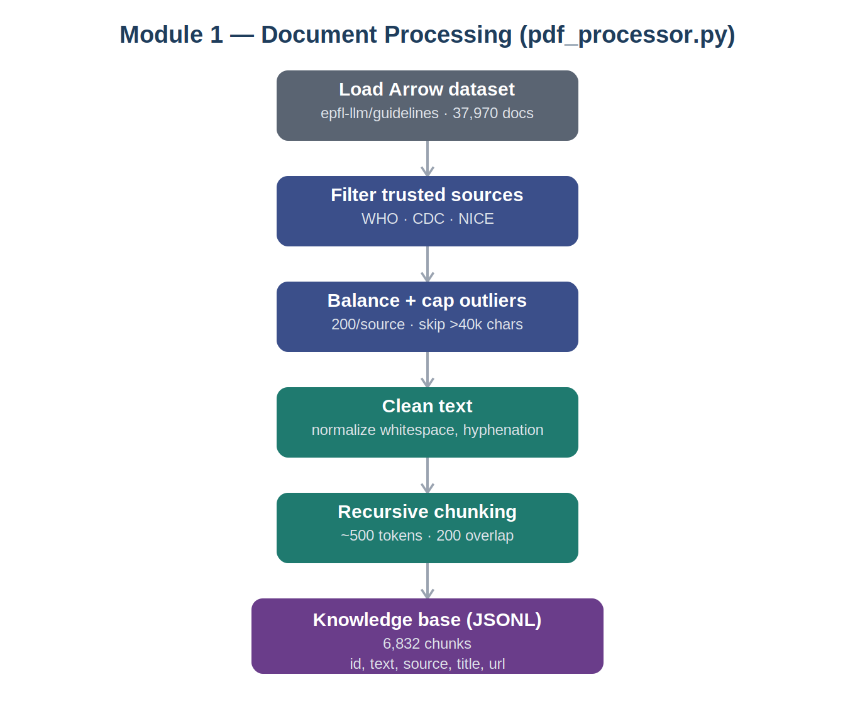
Figure 3 — Document processing module (pdf_processor.py).

5.3 Module 2 — Embedding
Encodes each chunk with the embedding model, normalises the vectors, and builds the FAISS index, saving the index and metadata to disk.
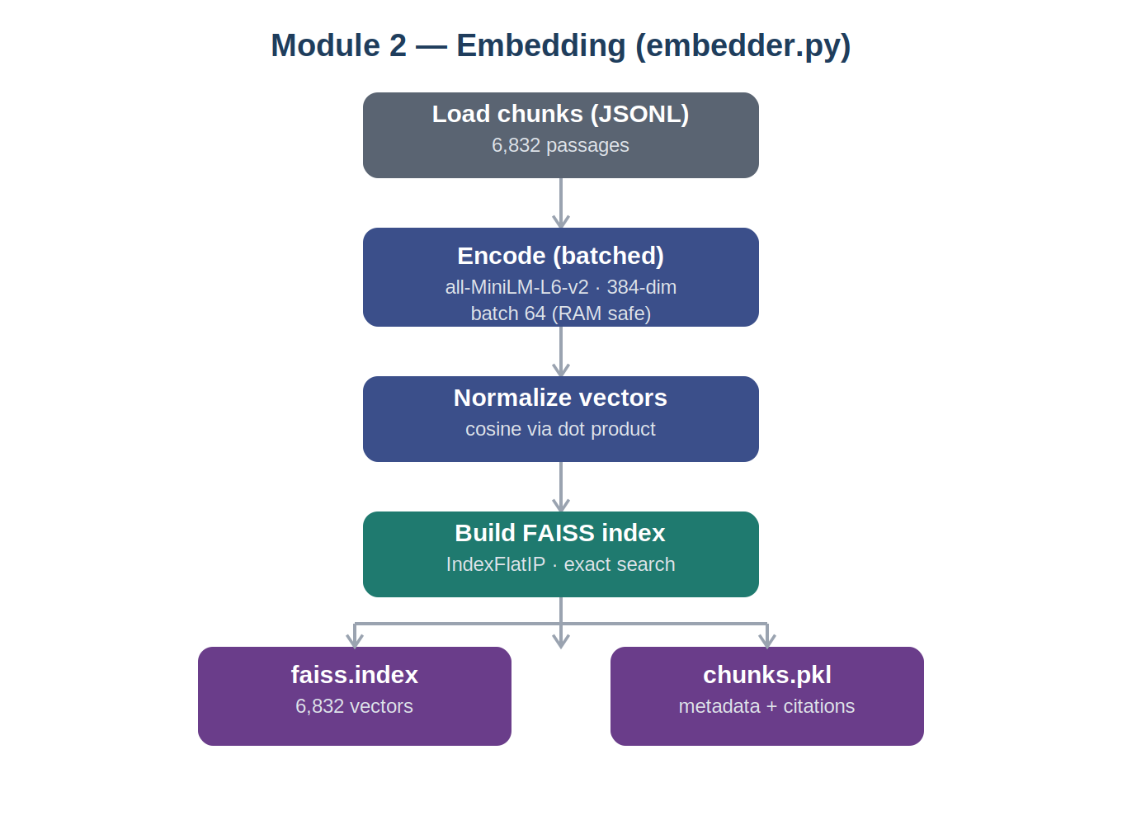
Figure 4 — Embedding module (embedder.py).

5.4 Module 3 — Vector search
Embeds the query, runs the two-stage retrieval (FAISS bi-encoder then cross-encoder re-rank), and returns the top five passages.
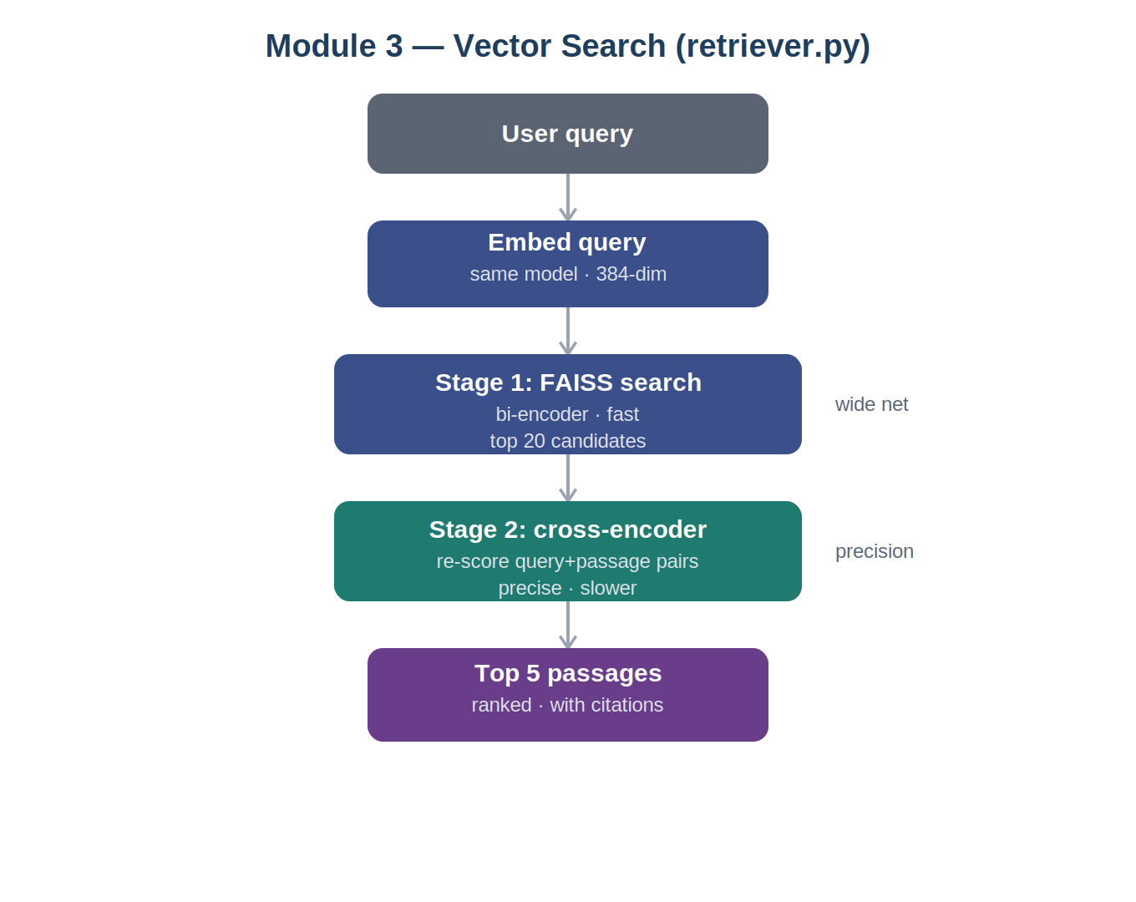
Figure 5 — Vector search + re-rank module (retriever.py).

5.5 Module 4 — RAG pipeline
The full loop: safety check, retrieval, grounded prompt assembly, LLM generation, and the cited answer.
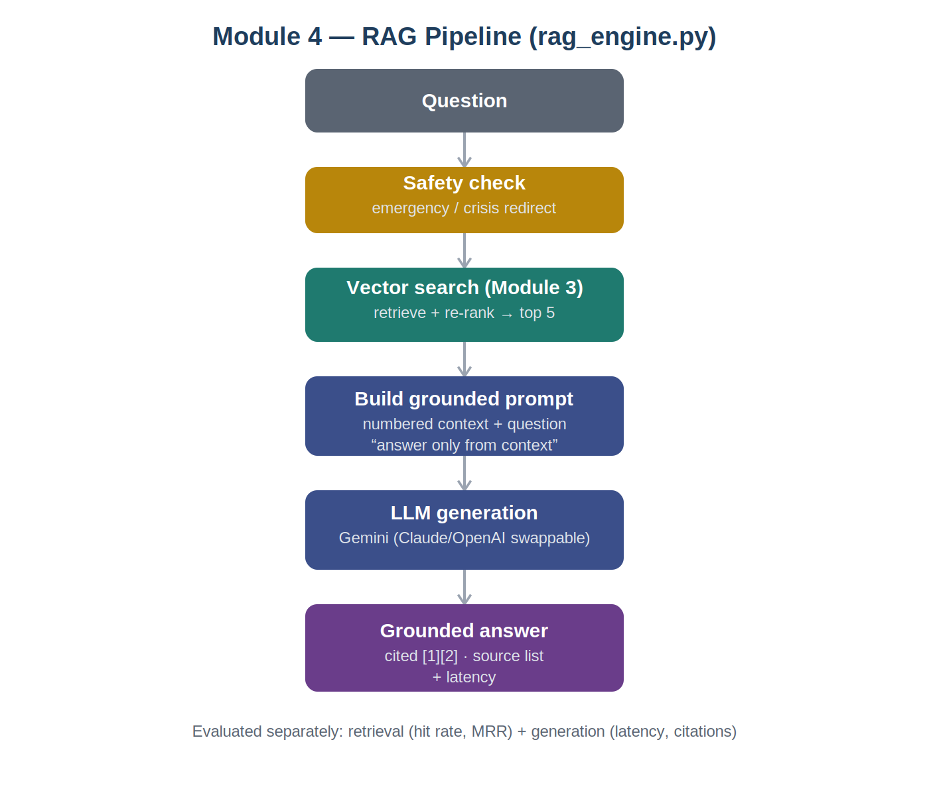
Figure 6 — RAG pipeline module (rag_engine.py).

5.6 Module 5 — Hospital document upload
The optional per-institution feature: an uploaded PDF is parsed with PyMuPDF, chunked and embedded with the same pipeline, and stored in an isolated per-hospital index that is never mixed with the public guidelines or other hospitals.
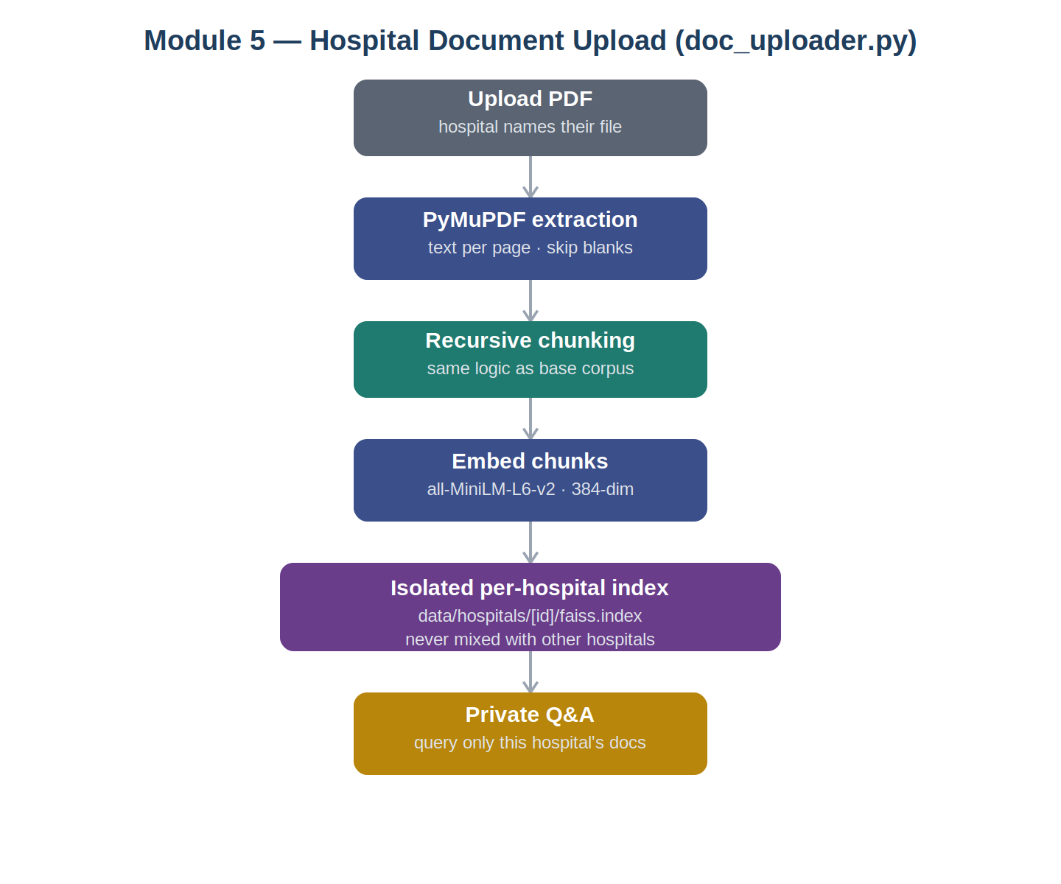
Figure 7 — Hospital document upload module (doc_uploader.py).

6. Benchmark Evaluation
Evaluation was treated as central. A ground-truth set of 15 questions was hand-written, each tied to a known-correct source document, so retrieval accuracy could be measured objectively. Retrieval and generation were evaluated separately, addressing the four required evaluation dimensions: retrieval accuracy, context relevance, response quality, and response latency.

6.1 Metrics used
Metric | Measures | Maps to spec dimension
Hit Rate @5 | Correct doc in top 5 | Retrieval accuracy
MRR | How highly the correct doc ranks | Retrieval accuracy
Re-rank lift | Hit rate after vs before re-rank | Context relevance
Citation rate | Answers cite their sources | Response quality
Latency | Time to produce an answer | Response latency

6.2 Retrieval results
Metric | Result | Interpretation
Hit Rate @5 (after re-rank) | 93.3% (14/15) | Correct doc in top 5 for 14 of 15
Hit Rate @5 (before re-rank) | 100% (15/15) | Bi-encoder alone found every correct doc
MRR | 0.900 | Correct doc almost always ranked first
Re-rank lift | -6.7% | Re-ranking slightly reduced top-5 hit rate
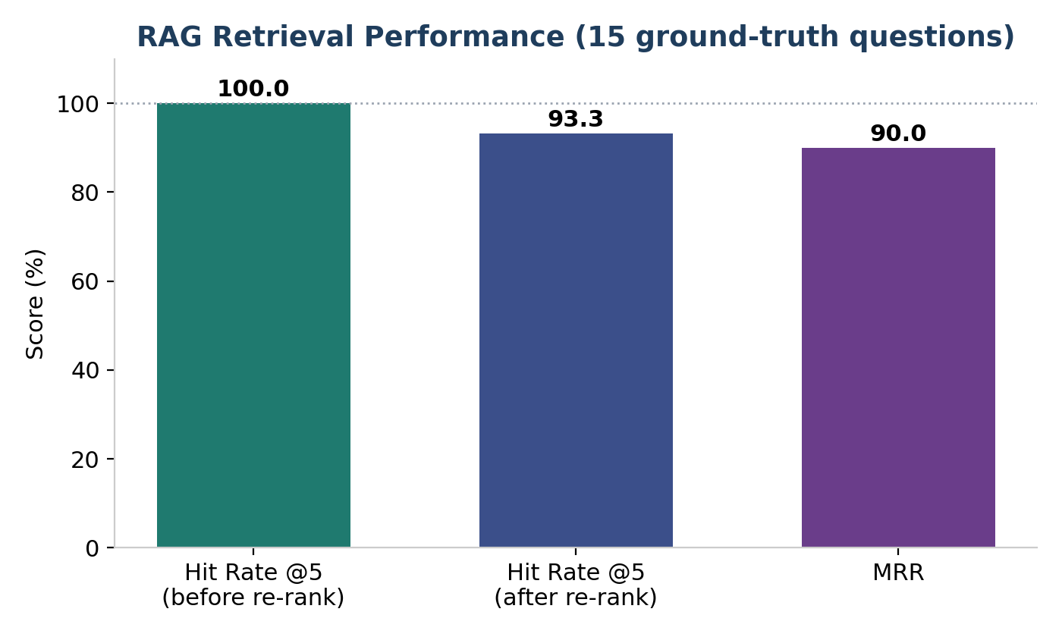
Figure 8 — Retrieval performance across 15 ground-truth questions.
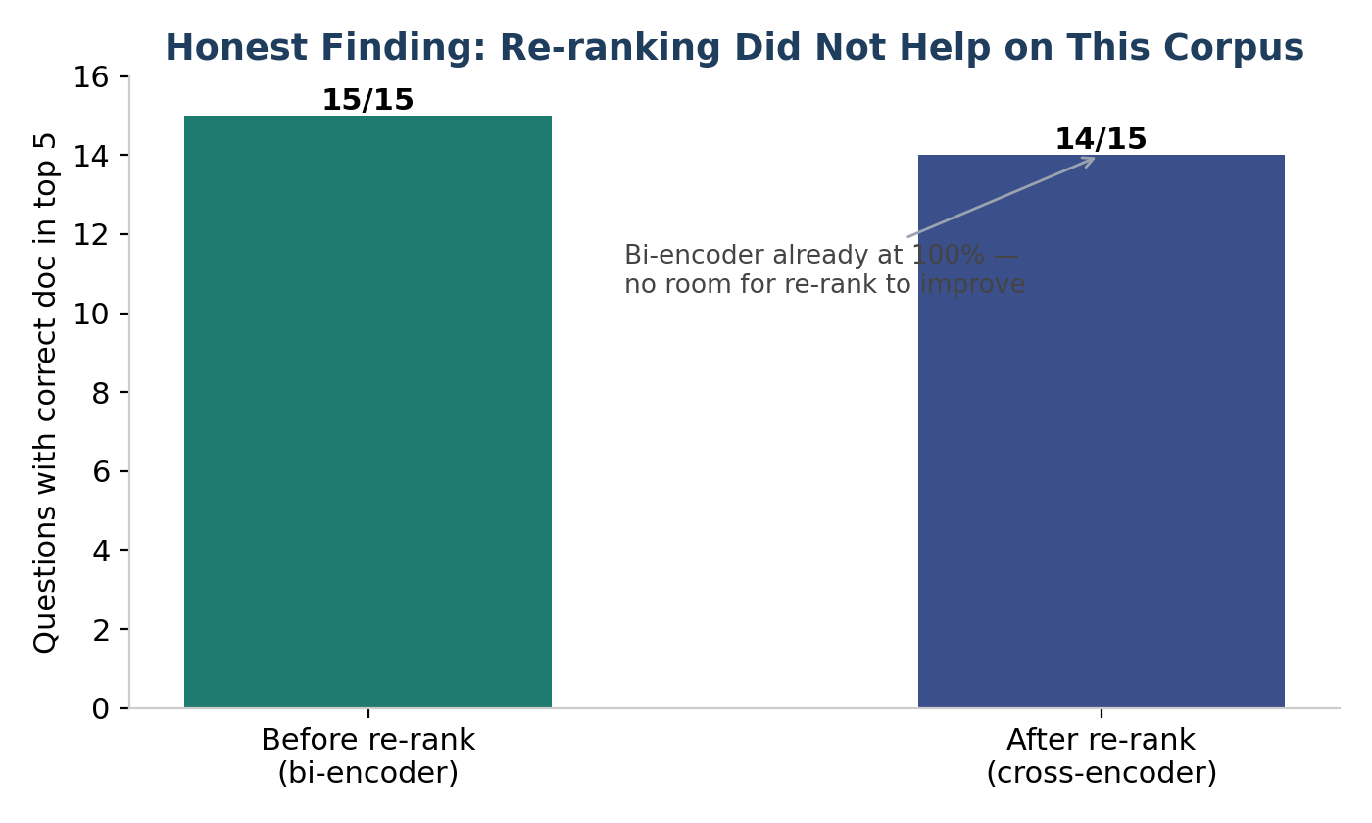
Figure 9 — The honest re-rank finding: no improvement on an already-saturated corpus.
The negative re-rank lift is the most important honest finding. Because bi-encoder retrieval was already saturated at a 100 percent hit rate, re-ranking had no room to help and on one question demoted an already-correct hit out of the top 5. This demonstrates a real principle: advanced techniques must be measured, not assumed. Re-ranking helps most when first-stage retrieval is weak, which was not the case on this clean corpus; it is retained because it satisfies the advanced-RAG requirement and would add value on a harder or noisier corpus.
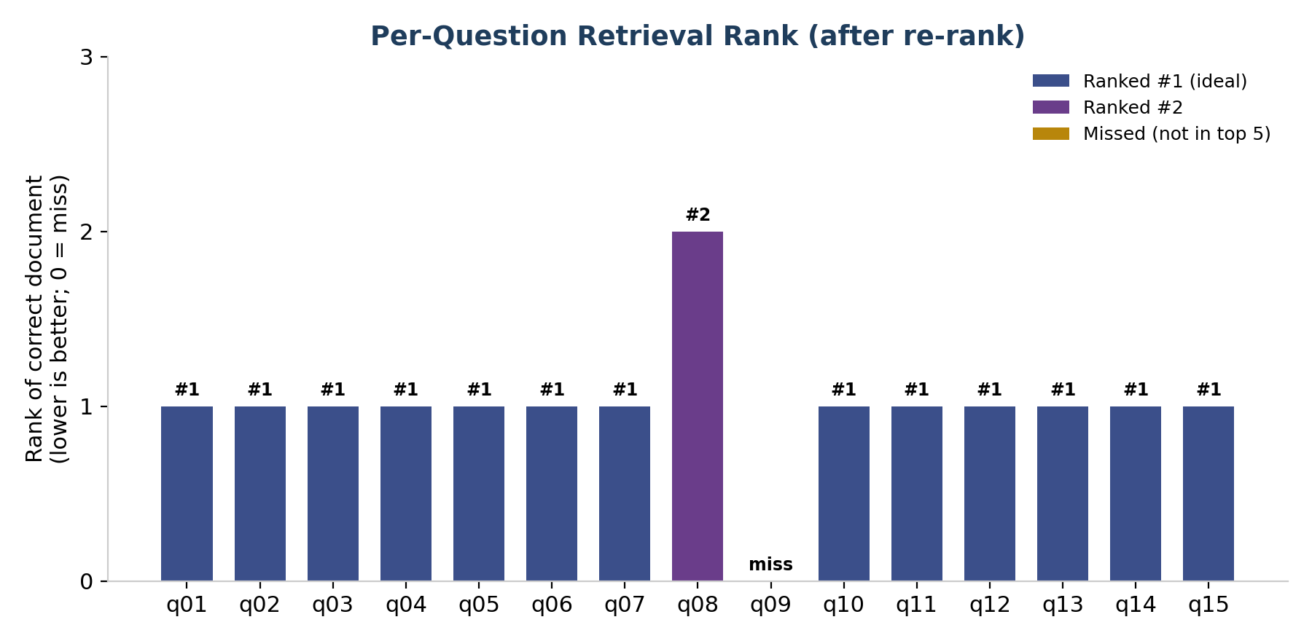
Figure 10 — Per-question rank of the correct document (one miss: q09).

6.3 Generation results
Metric | Result | Interpretation
Questions answered | 15/15 | No failures (after retry handling)
Average latency | 6.17 s | Interactive once models are warm
Citation rate | 93.3% | Answers reference their sources
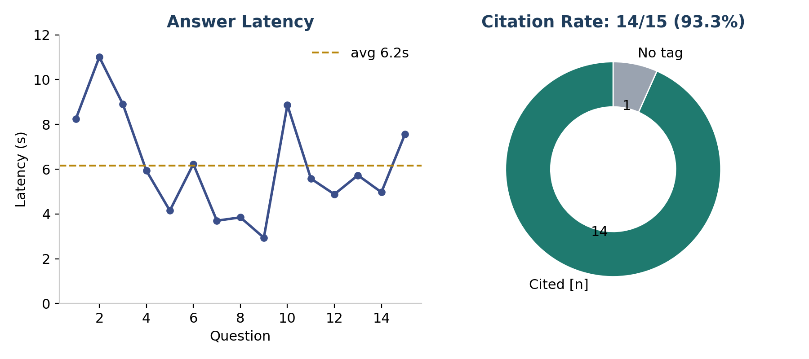
Figure 11 — Generation latency per question and overall citation rate.
Latency includes retrieval, re-ranking, and the LLM call; warm responses settle around three to four seconds. The grounding guard was verified: where the guidelines genuinely lacked a requested detail, the model said so rather than inventing content. A retry mechanism handled transient cloud 503 errors so a single server hiccup no longer aborts the evaluation.

6.4 Evaluation tooling choice
Off-the-shelf frameworks (Ragas, TruLens) were considered. A lightweight custom evaluation was chosen so every metric is transparent and computed from the project's own ground-truth set, avoiding extra dependencies and API cost. LLM-graded faithfulness is noted as a future enhancement.

7. Summary
Area | Week 2 | Week 3
Interface | Merged Dash apps, lazy tabs, restyle | Two-tab Streamlit RAG demo
Performance | Feature caching (~13 s → ~1 ms) | Batched embedding, cached models
Honesty | Confusion matrix, PR-AUC, weak targets shown | Ground-truth eval, honest re-rank finding
Data handling | Repo cleanup, gitignore | Per-hospital isolated upload (PyMuPDF)
Safety | — | Emergency / crisis redirect guard
Framework | — | Hand-built + LangChain LCEL engines
Across both weeks the consistent theme is honest engineering: real metrics over flattering ones, disclosed limitations, leakage vigilance, and documented rationale for every tool choice. Week 3 met its full specification (including all five tool comparisons) and added re-ranking, a safety guard, per-hospital document upload, and a parallel LangChain engine. The RAG engine exposes a clean interface ready to be served via an API to the planned Week 4 React frontend.

